Part 2 (a1): Input Validation and Error Handling

Question 1: Input Validation
In your current program, what happens if the user enters:
- Letters instead of numbers (e.g., "ABC def")?
- Outputs 0.00
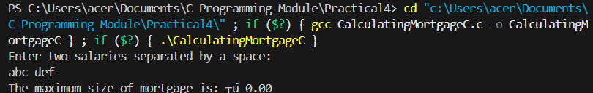

- Only one salary instead of two?
- The program waits for another salary and hangs. If just entered one input and terminated using CTRL+D it takes the 1st salary as larger salary and take 0 as 2nd salary.
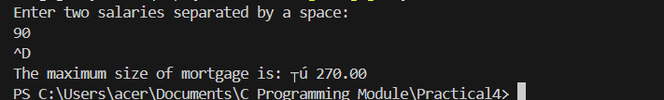

- Negative salaries?
- This calculates the values as numbers and not salaries as salaries cannot be negative.
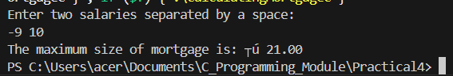

Task: Test your Part 1(c) program with these inputs and observe the behaviour. What security vulnerabilities do you notice?
- No input validation for alphabets as well as negative numbers and zero salary
- Garbage memory exposure and lack of infinite blocking for incomplete inputs Question 2: scanf return values
Research and answer:
- What does scanf return when it successfully reads input?
- Scanf returns 1 when it reads input, returns 2 in the program as it took 2 inputs. So, scanf returns the number of inputs successfully read.
- What does scanf return when it fails to read input?
- Scanf returns -1 for end of file and 0 for failure
- How can you use the return value to validate whether scanf was successful?
- By comparing return value with 2 for 2 successful inputs else failure.

Task: Write an if statement that checks whether scanf successfully read two double values. If it fails, display an error message and return 1 from main.
- if (scanf ("%lf %lf", &salary1, &salary2)! = 2) {printf("Error"); return 1;}

Question 3: Input buffer management
When scanf fails, invalid characters remain in the input buffer. This can cause problems for subsequent input operations.
- What happens if you don't clear the input buffer after scanf fails?
- Invalid inputs remain which can cause freeze or program hang during input operations. This makes the user unable to input in the program.
- How can you clear the input buffer? (Hint: use getchar () in a loop)
- Using getchar () in a loop until a newline is found

Task: Add code to clear the input buffer when scanf fails. Use: while (getchar ()! = '\n');
- if (scanf ("%lf %lf", &salary1, &salary2)! = 2) {while (getchar ()! = '\n' && getchar ()! = EOF);}

Question 4: Creating a validation function
Good programming practice separates input reading from validation.
- What should a function named read Salaries do?
- Ask the user for salary input, reading the value, and performing basic validation.
- What parameters should it accept? (Hint: use pointers to modify salary variables)
- accept pointers to double variables to modify them
- What should it return to indicate success or failure? (Hint: use bool type)
- Boolean true for success and false for failure
- Before using pointers, what defensive check should you perform?
- Check the pointer addresses are not Null

Question 5: Range validation
Even if scanf succeeds, the input values might be unreasonable.
- What is a reasonable minimum salary? (Hint: 0.0)
- 0.0
- What is a reasonable maximum salary? (Hint: £1,000,000)
- 1000000.0
- Why is it important to set upper limits on input values?
- To make sure salary isn’t negative and prevent arithmetic overflow

Question 6: Overflow protection
In the mortgage calculation, you multiply the larger salary by 3. This could cause integer overflow.
- What is LLONG_MAX? (Hint: check limits.h)
- Maximum value of long long int
- Before multiplying larger salary by 3, how can you check if overflow will occur?
- By checking if the result exceeds LLONG_MAX
- How can you indicate an error occurred in calculate Mortgage function?
- Return -1 for calculation failure
Question 7: Error handling in main
Your main function should check all error conditions and respond appropriately.
- What should happen if read Salaries fails?
- What should happen if validate Salary fails?
- What should happen if calculate Mortgage returns -1?
- Each of the above occurrence should print an error message and exit

Question 1: Why limit retry attempts?
- What security risk exists if a program allows unlimited retry attempts?
- Allows DoS attacks
- How could an attacker exploit unlimited retries? (Hint: think about Denial of Service)
- Flood the program with unlimited retries forcing it to crash, freeze or even get access
- What is a reasonable number of retry attempts for a user? (3? 5? 10?)
- 3 to 5

Task: Define a constant MAX_ATTEMPTS with value 3.
- #define MAX_ATTEMPTS 3

Question 2: Loop design for retries
- What type of loop is best for retry logic? (for, while, or do-while?)
- For loop or while loop
- What two conditions should continue the loop? (attempts and validity)
- Attempts<MAX_ATTEMPTS and wrong inputs (! inputValid)
- When should the loop stop?
- Attempts=MAX_ATTEMPTS or required input received

Question 3: Implementing retry logic
Within your retry loop:
- What should happen if read Salaries fails?
- Attempts++, print error, show remaining attempts and continue
- What should happen if validate Salary fails?
- Attempts++, print error, show range, show remaining attempts and continue
- How do you inform the user of remaining attempts?
- Print remaining attempts of MAX_ATTEMPTS
- What keyword continues to the next loop iteration? (Hint: continue)
- Continue;

Question 4: Handling maximum attempts exceeded
- After the retry loop exits, how do you know if the user exceeded maximum attempts?
- Wrong input value and attempt>=MAX_ATTEMPTS
- What should the program do if maximum attempts are exceeded?
- Print maximum attempts reached and terminate the program

Question 5: Calculating after successful input
- If the loop exits with valid input, what happens next?
- Exit loop, Call the function and calculate the result
- Should you still check the calculate Mortgage return value?
- Yes, to check if the result is still within valid range to prevent overflow

